**Creating a User in SQL Server Management Studio**

Open SQL Server Management Studio.

Connect to your database

On the folder tree on the left, expand Security.

Right-click the Logins folder, then click New Login.

Type the username you want to create into the Login name field.

Select SQL Server Authentication.

Enter and confirm a password for that user.

Clear the check box for Enforce password policy to make sure that you are not having to reset your SQL Server password frequently.

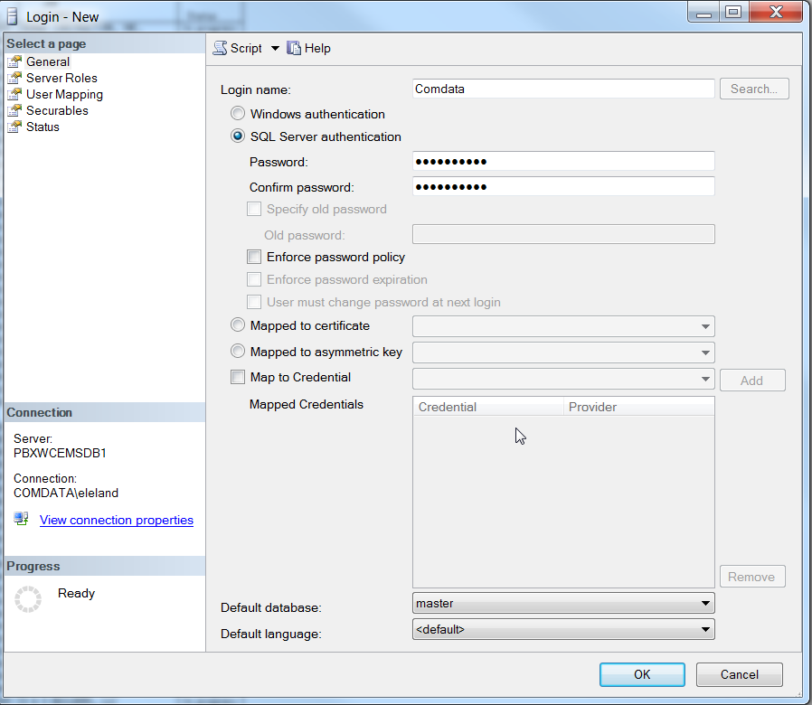

Click Server Roles on the left-hand menu.

Select the boxes for public and sysadmin.

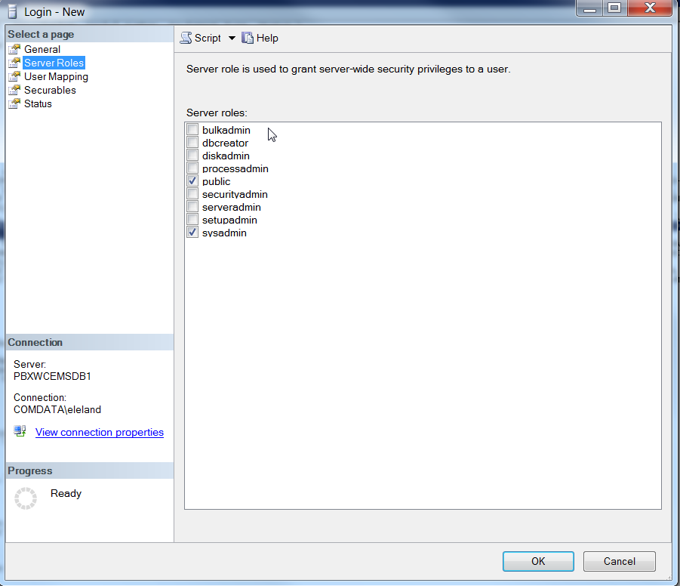

Click User Mapping on the left-hand menu.

Select the boxes for db datareader and public.

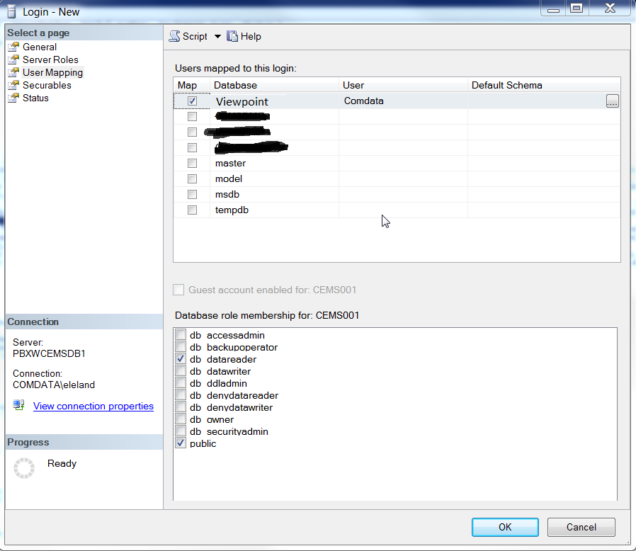

Click OK.

**SQL tables**

bJCCT - Job Cost Type

bEMCT - Equipment Cost Category

bHQCO - Companies

bEMCC - Equipment Cost Code

bJCCM – Division / Department

bHQMA - Audit tables

bEMCC - Equipment Cost Code

bEMCX - Equip Cost Type

bEMCT - Equipment Cost Type Master information

bEMEM - Equipment

bGLAC - GL Account

bJCJP - Phases

SMCostType - Service Work Order

vSMWorkOrderScope – Service Work Order Scope

bEMWH - Equipment Work Order

bEMWI – Equipment Work Order Items

bJCMP – Project Manager

bJCJM – Jobs